EXPERIMENT 2

.

# AIM:

To implement programs for visualizing time series data.

# STEPS TO IMPLEMENT:

from pandas import read_csv

from matplotlib import pyplot

series = read_csv('C:/Users/exam/Downloads/daily-min-temperatures.csv', header=0,

index_col=0, parse_dates=True, squeeze=True)

print(series.head())

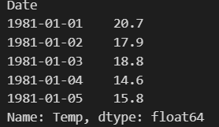

from matplotlib import pyplot

series = read_csv('C:/Users/exam/Downloads/daily-min-temperatures.csv', header=0,

index_col=0, parse_dates=True, squeeze=True) series.plot()

pyplot.show()

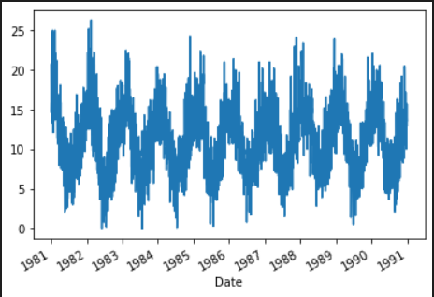

from pandas import read_csv from matplotlib import pyplot

series = read_csv('C:/Users/exam/Downloads/daily-min-temperatures.csv', header=0, index_col=0, parse_dates=True, squeeze=True)

series.plot(style='k.')

pyplot.show()

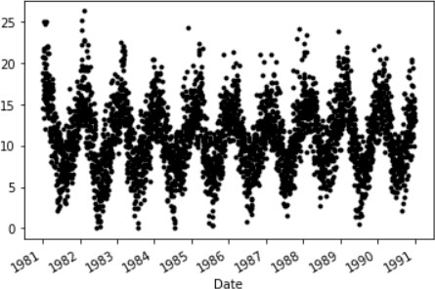

from pandas import read_csv from pandas import DataFrame from pandas import Grouper from matplotlib import pyplot

series = read_csv('C:/Users/exam/Downloads/daily-min-temperatures.csv', header=0, index_col=0, parse_dates=True, squeeze=True)

groups = series.groupby(Grouper(freq='A'))

years = DataFrame()

for name, group in groups:

years[name.year] = group.values years.plot(subplots=True, legend=False) pyplot.show()

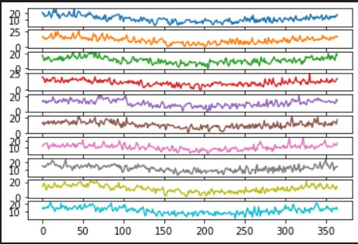

from pandas import read_csv from matplotlib import pyplot

series = read_csv('C:/Users/exam/Downloads/daily-min-temperatures.csv', header=0, index_col=0, parse_dates=True, squeeze=True)

series.hist()

pyplot.show()

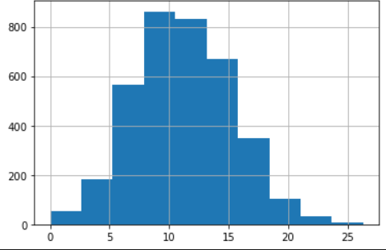

from pandas import read_csv

from matplotlib import pyplot

from pandas.plotting import autocorrelation_plot

series = read_csv('C:/Users/exam/Downloads/daily-min-temperatures.csv', header=0,

index_col=0, parse_dates=True, squeeze=True)

autocorrelation_plot(series) pyplot.show()

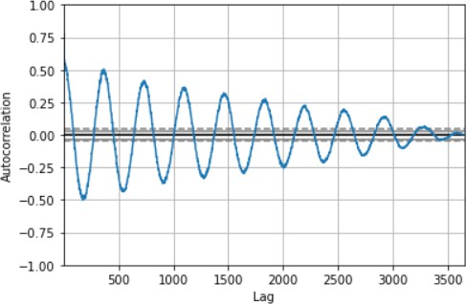

from pandas import read_csv from matplotlib import pyplot

from pandas.plotting import lag_plot

series = read_csv('C:/Users/exam/Downloads/daily-min-temperatures.csv', header=0, index_col=0, parse_dates=True, squeeze=True)

lag_plot(series)

pyplot.show()

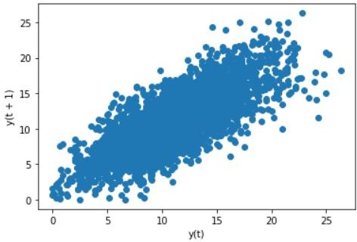

from pandas import read_csv

from matplotlib import pyplot

series = read_csv('C:/Users/exam/Downloads/daily-min-temperatures.csv', header=0,

index_col=0, parse_dates=True, squeeze=True)

series.plot(kind='kde') pyplot.show()

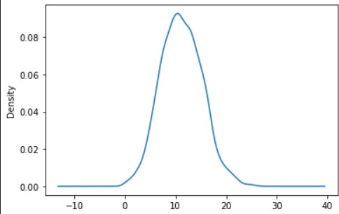

# RESULT:

The program to implement programs for visualizing time series data. was executed

successfully.